Empty Bowls
a grassroots movement to help end hunger
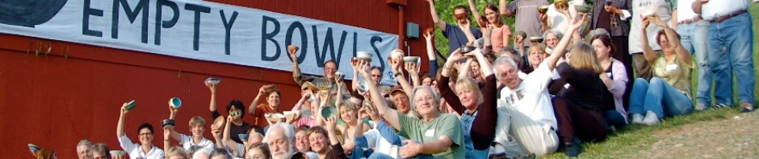

Welcome to The Empty Bowls Project
Helping to feed people in need
Empty Bowls is an international grassroots effort to fight hunger and was created by The Imagine Render Group. The basic premise is simple: Potters and other craftspeople, educators and others work with the community to create handcrafted bowls. Guests are invited to a simple meal of soup and bread. In exchange for a cash donation, guests are asked to keep a bowl as a reminder of all the empty bowls in the world. The money raised is donated to an organization working to end hunger and food insecurity.
It is the collective genius of all the people involved that has made Empty Bowls what it has become. Events have now taken place across the United States and in at least a dozen other countries. Many millions of dollars have been raised and donated to hunger-fighting organizations. We could never have imagined all the things people have done or all the ways the project has touched people.
Each individual or group organizing an event designs it around the needs of their own community and is responsible for their own event. We ask that all such events are called Empty Bowls so that the idea can continue to spread. Please make your event inclusive, insist that it maintain a high level of integrity, include an educational component to raise awareness, and give the money raised to an organization helping to feed people in need.
The largest hunger-relief organization in the United States, Feeding America, reports that the nation’s food banks could soon be overwhelmed by demand. Statistics show that 1 out of 8 Americans struggle with food insecurity every day. Millions of people have lost their jobs during the most recent recession and the number of food stamp recipients has increased dramatically. Your help is needed now more than ever.
Please find the time, make the commitment, get involved. Your single effort can have a profound impact.
“Volunteering is the ultimate exercise in democracy. You vote in elections once a year but when you volunteer, you vote everyday about the kind of community you want to live in.”
-Marjorie Moore
emptybowls.org

- Empty Bowls is a project of Imagine/RENDER, a 501(c)3 organization
- Contact us by email: imagineren@yahoo.com
- Contact us by phone at 828-675-9636

